

OPERATING SYSTEMS PROJECT
PROJECT NAME:
CPU SCHEDULING SIMULATOR (FCFS|SJF|ROUND ROBIN)

TEAM MEMBERS:
- KEWAL
- HASEEB

Instructor:
Engr. Unzela Talpur

- Introduction:
Multi-programming consists of multiple programs running simultaneously on a computer. In such an operating system, many jobs run concurrently. In multi-programming systems, the OS must select a program to execute from those waiting in main memory. This selection is made through CPU scheduling algorithms.

- Project Description:
This project is a Python Desktop Application which is basically an emulation of three major scheduling algorithms, namely First Come First Serve, Shortest Job First, and Round Robin. The application has a graphical user interface through which data is entered.

- Objectives:
- To show the functionality of OS scheduling algorithms.
- To find and analyze critical parameters such as Waiting Time (WT), Turnaround Time (TAT), and Completion Time (CT).
- To create a user-friendly GUI using the tkinter module.

4.Key Terms and Formulas:
- To calculate the efficiency of the algorithms, the following equations have been programmed.
- Arrival Time (AT): The time when the process arrives in the ready queue
- Burst Time (BT): The time needed by a process to execute in the CPU
- Completion Time (CT): The time when the process completes its execution.
- Turnaround Time (TAT): The time that the process stays in the system
TAT = CT – AT
- Waiting Time (WT): Total time the process waits in the ready queue.
WT = TAT -BT
- Algorithms Implemented:

A). First-Come, First-Served (FCFS)
- Principle: The first process to make the request for the processor will be served first.
- Type: Non-Preemptive
- Technique: Processes are prioritized by their arrival time and are processed accordingly.

B). Shortest Job First (SJF)
- Principle: Linked to every process is its next CPU burst length.
- The CPU goes to the process having the least burst time.
- Type: Non-preemptive (for this particular simulation).
- Algorithm: At any instant T, the algorithm checks all processes available and chooses the one with the least Burst Time.

C). Round Robin (RR)
- Principle: Created for time-sharing systems. A small amount of CPU time is allocated to each process, called a Time Quantum.
- Type: Preemptive.
- Operation: Uses a Circular Queue structure (using collections. Deque) until all processes are completed.
5.Tools & Technologies Employed:

- Programming Language: Python 3.x
- GUI Framework: Tkinter (used for windows, buttons, and display components)
- Data Structures:
- Lists (used for managing processes)
- Deque (used for optimizing round-robin queue operations)
- Operating System: Kali Linux

- Software Architecture:
- The application is developed following the Object-Oriented Programming (OOP) methodology.
- __init__: Performs initializations such as window initialization and creating data structures.
- setup_ui: Creates the UI structure, the colors (black and neon theme), and the input fields.
- add_process: Validates user input and creates a list of processes.
- fcfs() / sjf() / round_robin(): Logical functions representing the algorithms.
- print_results: Helps in formatting the output table.

- User Manual:
- Process ID Enter: A unique ID for the process.
- Arrival Time Enter: When the process arrives in the queue (e.g., 0, 1, 2).
- Burst Time Enter: Execution time needed.
- Process Add: Click to add the process to the existing list.
- Time Quantum: Needed only for Round Robin scheduling.
- Simulate: Click on FCFS, SJF, or RR to see the results.
SOURCE CODE
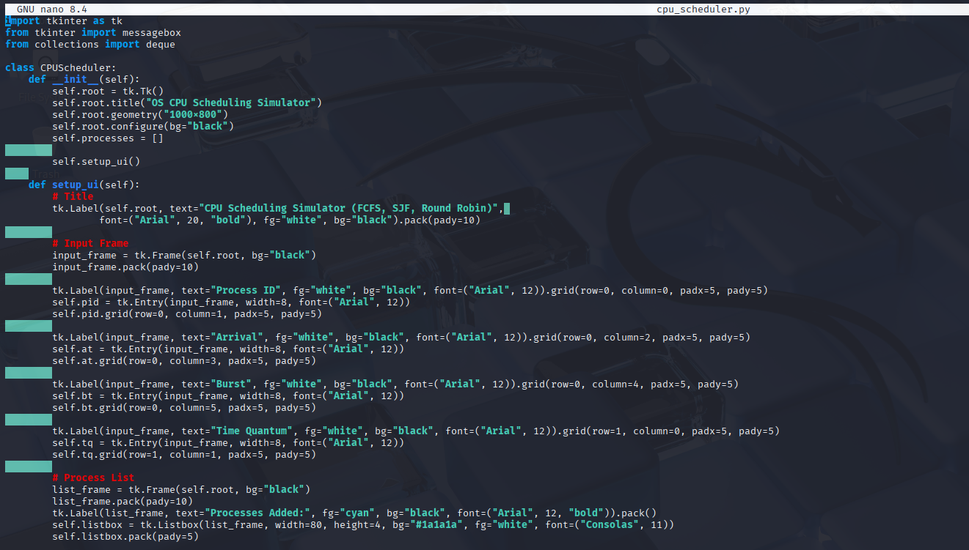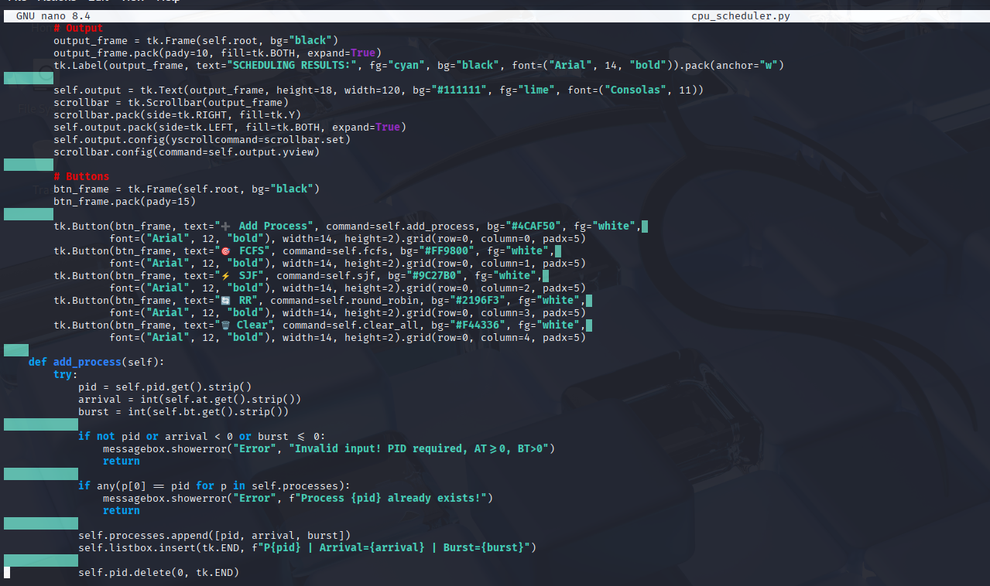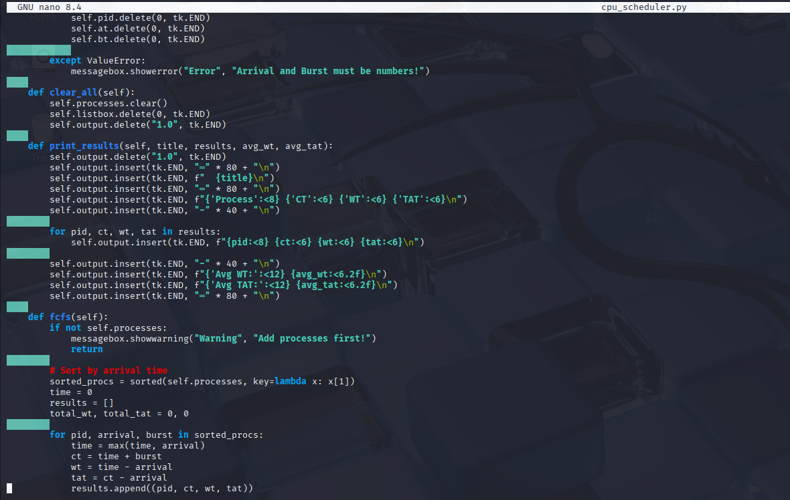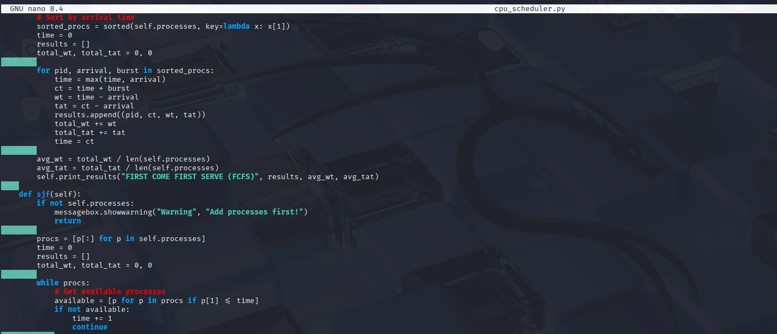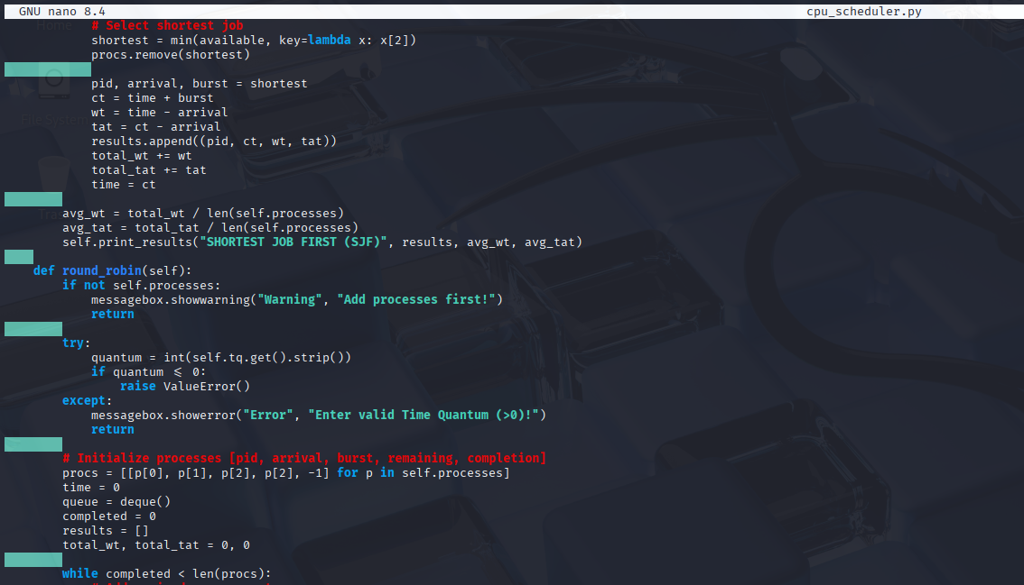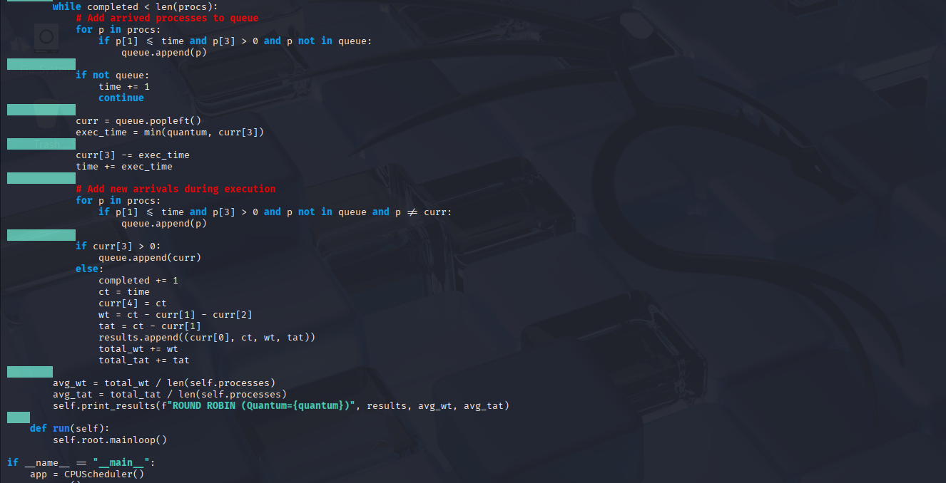

OUTPUT

